# Readme

Project by:

* Ahmed Elamin (aalihadaby@yahoo.com)
* Mohamed Almagboul (Mohamed-Almagboul@hotmail.co.uk)
* Rajesh Mahalingam (rajeshmahalingam@outlook.com)
* Georg Stubenrauch (georg.stubenrauch@gmx.de) (group speaker)

Used software / database:

* Eclipse (Version: Mars Release (4.5.0), Build id: 20150621-1200)
* MySQL (Port 3306, username: root, password: riazdh)

Additional information about our program:

1. MySQL was used (information above)
2. Creation or loading of a database is necessary to be able to create or import geometries
3. When creating a database the table “geometries” is always created at once, fields of this table:  
   * ID: INTEGER, PRIMARY KEY, AUTO_INCREMENT
   * TYPE: VARCHAR
   * X1: INTEGER
   * Y1: INTEGER
   * X2: INTEGER
   * Y2: INTEGER
4. Geometries can be imported from and exported to a CSV-file, if its data has the necessary structure (3.), sample dataset is provided
5. Interaction with canvas only possible if one of the different radio buttons are selected and you are connected to a database
6. Drawing of geometries:  
   * points: with a single click inside the canvas
   * lines: by dragging the mouse inside the canvas
   * rectangles: by dragging the mouse inside the canvas
7. Editing of geometries:  
   * Delete: either with a single click or by dragging the mouse (area displayed by  
      rectangle), to **delete** a **line** with a **single click**, you have to click at the left or right end,  
      to **delete** a **rectangle** with a **single click**, you have to click at the top  
      left or bottom right corner of the geometry (see Figure 1)
   * Select: either with a single click or by dragging the mouse (area displayed by  
      rectangle), selected geometries are blue,  
      to **select** a **line** with a **single click**, you have to click at the left or right end, to **select** a **rectangle** with a **single click**, you have to click at the  
      top left or bottom right corner of the geometry (see Figure 1)
   * Unselect: with a single click inside the canvas all selected geometries are  
      deselected
   * Move: to be able to move a geometry, you have to first select a geometry,  
      thereafter the coordinates of the first point in the table (X1|Y1) is  
      changed to the coordinates of the mouse click,  
      at the moment only single geometries should be moved,  
      otherwise they all get the same X1/Y1 coordinates which causes  
      them to overlap each other
   * X/Y: display of the mouse coordinates inside the canvas
8. Database:  
   * Create: new “popup menu” opens, enter name of the new database,  
      with a click on the button this database is created as well as the  
      table “geometries”
   * Load: new “popup menu” opens, enter name of the new database,  
      with a click on the button this database is loaded as well as the  
      geometries inside are displayed in the canvas
9. File handling:  
   * Import: choose a CSV-file to import with the help of a file-chooser,  
      the geometries inside will be inserted into the database, you are  
      connected and the displayed inside the canvas  
      (-> only possible if you are connected to a database with  
      a “geometries” table)
   * Export: choose the folder and the filename of the new or existing CSV-file,  
      if the file does not exist, make sure to add “.csv” at the end,  
      all the entries of the table “geometries” will be written into the file,  
      can then be used to import into another database

In addition to the project as a compressed file, we are adding the project folder as well as the folder libraries that contains the driver for the database connection.

We hope that everything will be working for.

If there are nevertheless any questions, please feel free to contact us.

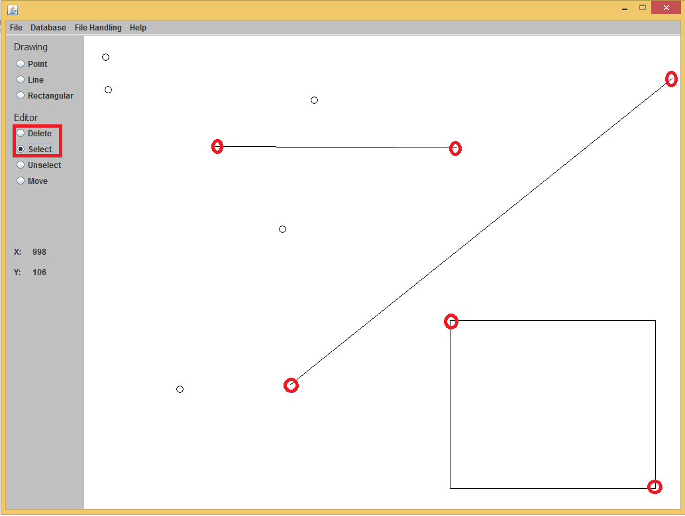

Figure 1: Example about how to select or delete a line or rectangle by a single click